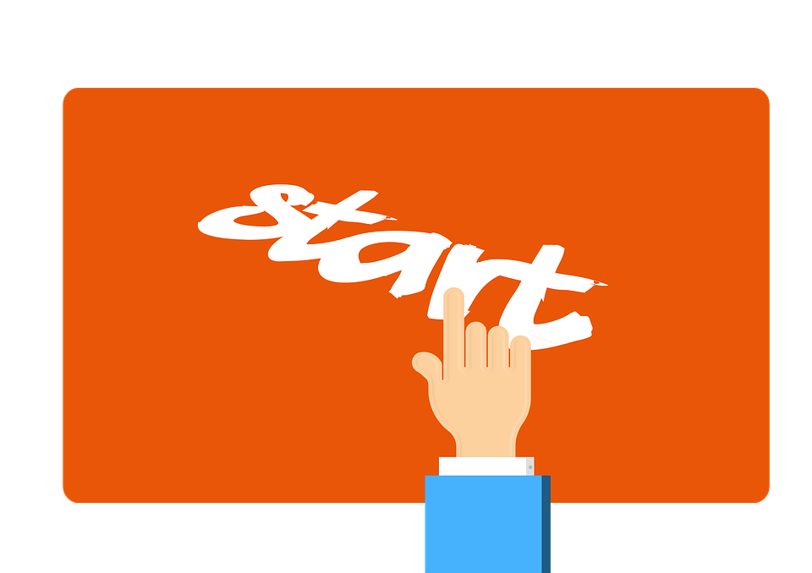 Morning Routine, 8:55 - 9:10
- Hang coats on hooks, place book bags in bins, put lunches in cart.
- Unstack chairs for your learning station.
- Identify your lunch choice from the SmartBoard.
- Listen closely to morning announcements.
- Copy assignments from the teacher board into your planner with homework in red.
- On Friday, listen to Friday Folder announcements/handout information.
- Raise your hand when your planner is ready for teacher signature.
- Get your materials ready for morning block and line up quietly in the back of the classroom, ready for our switch.
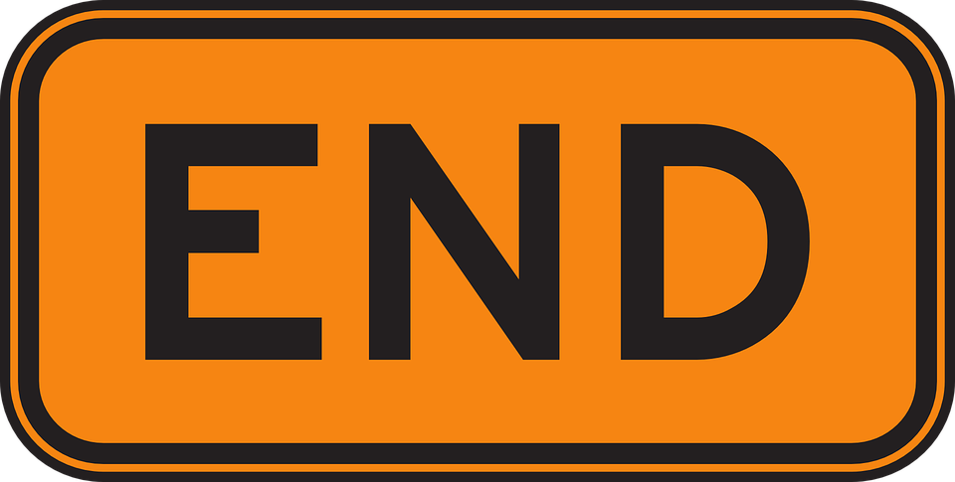 Afternoon Routine, 3:25 - 3:30
- Place binder and books on your desk.
- Stack chairs for your learning station.
- Get your coat and book bag/lunch box and return to your desk.
- Pack your binder, planner, and other needed materials in your bookbag.
- Complete Classroom Helper responsibilities.
- Place extra materials/pencils from desks and floor in your table basket.
- Line up quietly in the back of the classroom when finished packing up and completing helper responsibilities.
- When everyone is ready, line up in the hallway with car riders and walkers single file on the right side and bussers single file on the left side of the hallway.

